**Laboratory Exercise 9.1 - Oracle Transaction Management**

1. Open the text file called *SQLTransactionManagement.txt* stored in this directory.

2. Copy each statement (one at a time) in section (a), and paste them into SQL*Plus at the SQL> prompt to see the effects of ROLLBACK and COMMIT.

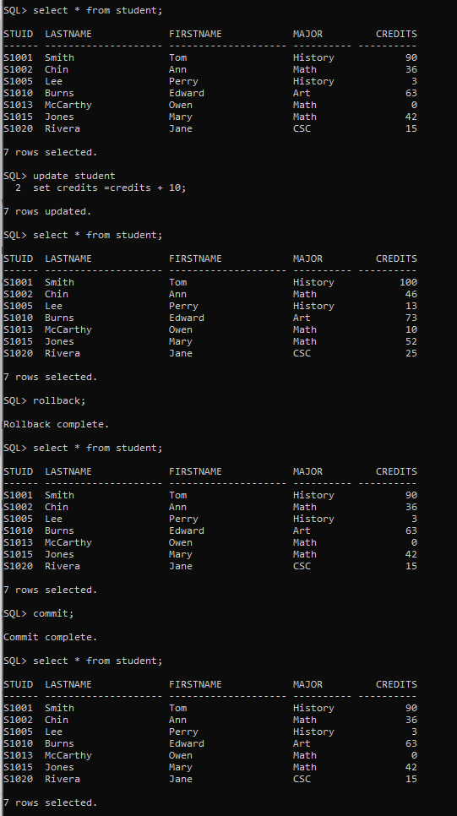

Figure

3. Copy each statement (one at a time) in section (b), and paste them into SQL*Plus at the SQL> prompt to see the effects of a SAVEPOINT.

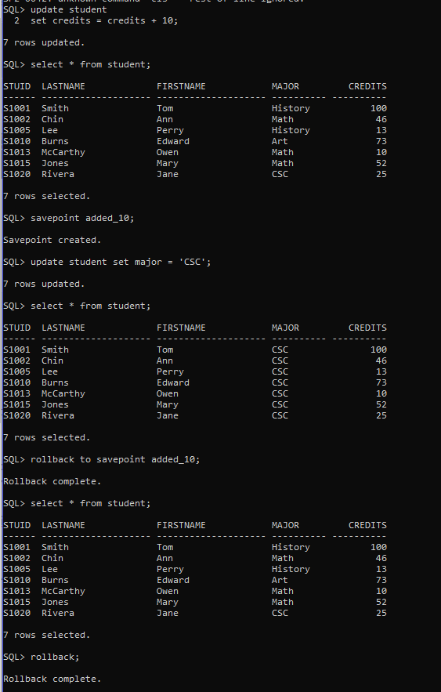

Figure

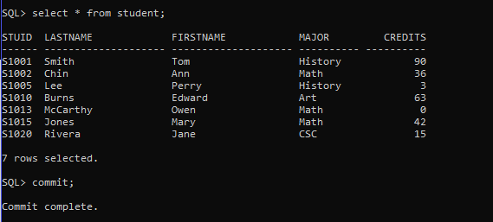

Figure

4. Copy each statement (one at a time) in section (c), and paste them into SQL*Plus at the SQL> prompt to see the effects of a SET TRANSACTION READ ONLY versus READ WRITE and naming a transaction.

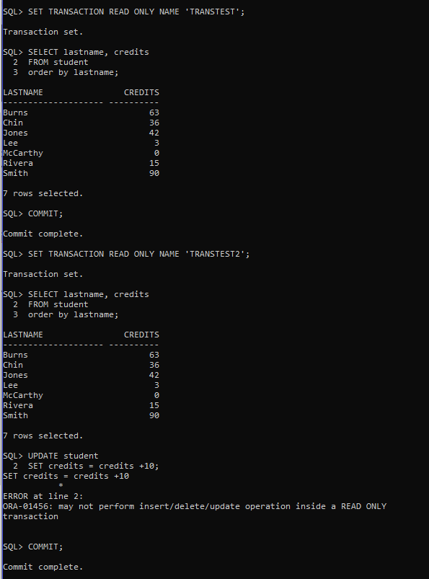

Figure

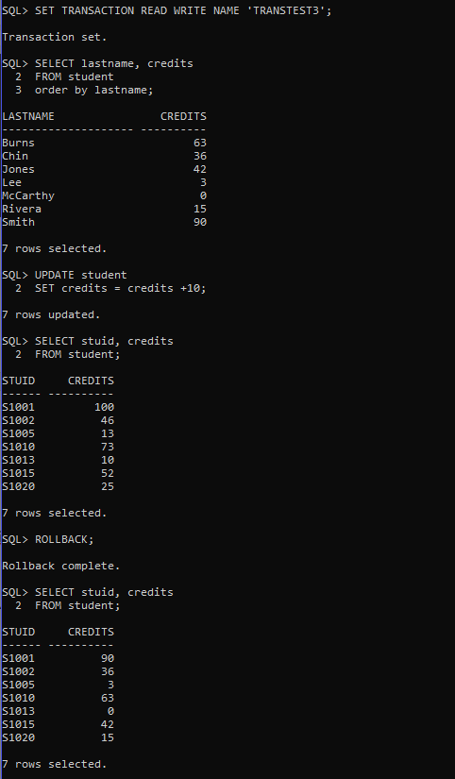

Figure

5. Make up a named transaction containing savepoints that illustrates the various options you used in this exercise.

**SET TRANSACTION READ WRITE NAME 'NEW_TRANSACTION';**

**SELECT**

**EMPID,**

**FIRSTNAME,**

**LASTNAME,**

**SALARY**

**FROM WORKER;**

**UPDATE WORKER**

**SET SALARY=SALARY+10000;**

**SELECT**

**EMPID,**

**FIRSTNAME,**

**LASTNAME,**

**SALARY**

**FROM WORKER;**

**SAVEPOINT SALARY_INCREASED_BY_10000;**

**UPDATE WORKER**

**SET LASTNAME = 'MARTINS';**

**SELECT**

**EMPID,**

**FIRSTNAME,**

**LASTNAME,**

**SALARY**

**FROM WORKER;**

**SAVEPOINT LAST_NAME_MARTINS;**

**UPDATE WORKER**

**SET FIRSTNAME = 'RODRIGO';**

**SELECT**

**EMPID,**

**FIRSTNAME,**

**LASTNAME,**

**SALARY**

**FROM WORKER;**

**ROLLBACK TO SAVEPOINT LAST_NAME_MARTINS;**

**SELECT**

**EMPID,**

**FIRSTNAME,**

**LASTNAME,**

**SALARY**

**FROM WORKER;**

**ROLLBACK TO SAVEPOINT SALARY_INCREASED_BY_10000;**

**SELECT**

**EMPID,**

**FIRSTNAME,**

**LASTNAME,**

**SALARY**

**FROM WORKER;**

**-- RETURNING TO THE INITIAL VALUES**

**ROLLBACK;**

**COMMIT;**

6. Execute the transaction in the database and show the results.

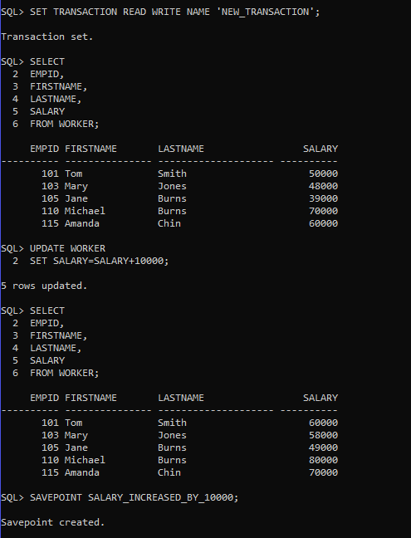

Figure

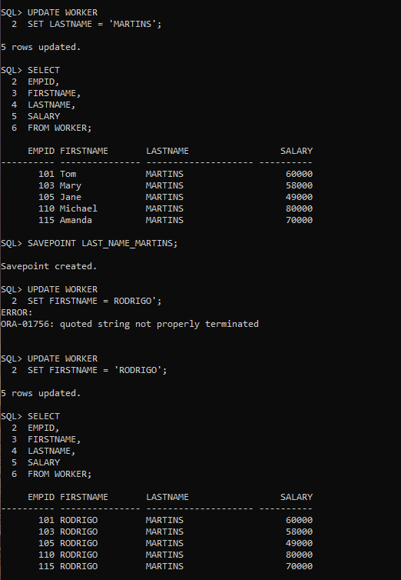

Figure 7

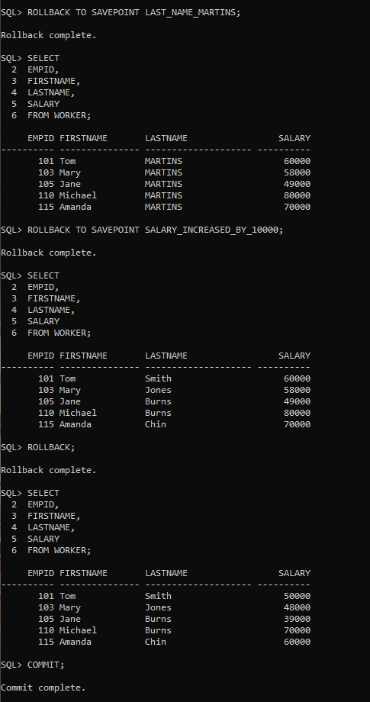

Figure 8